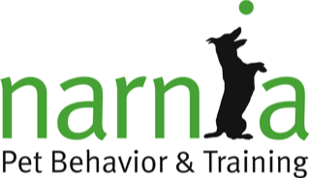 | Class Registration Form

Please note that space in class is limited and fills quickly. Submitting the registration form does not ensure space in your requested class. We will contact you when we receive your registration form to confirm your class selection. Payment is required to hold your place in class.

About You…
Name
Address
City |  | State |  | ZIP
Home Phone |  | Cell Phone
Email

About Your Pet…
Pet’s Name |  |  | Date of Birth
Breed
Vet Clinic |  |  | Town
Adoption Information
If your pet is adopted from an animal shelter or rescue, please provide the information below. Otherwise, you may leave it blank. Adopted animals receive a 10% discount on classes at Narnia. Proof of adoption is required.
Shelter or Rescue Name

Class and Payment Information…
Select your class
Puppy Kindergarten ($130)  Beginning Obedience ($130)  Puppy Continuing ($115)  Manners & Self Control ($115) |  |  |  |  | Nose Work ($130)  Private Lesson ($75)  Behavior Consultation (Call for Details)  Other:
Class Location: |  |  | Plainfield Lisle
Class Date: |  |  |  | Class Time: |  |  |  | Orientation Date:
VISA/MC #: |  |  |  |  |  |  | Exp MM/YY: |  |  |  | CVV:

Please Note…
- Refund Policy: If you are unable to attend the class for which you have registered, we will gladly refund your payment in full before class starts. After class start date, we cannot refund your payment.
- Children younger than 5 years of age may NOT attend class for safety reasons. Children 5 to 17 years old must be accompanied by an adult.
- Prices are subject to change without notice.

